**GROUP ASSIGNMENT – MEETING MINUTES**

|  |  |
| --- | --- |
| **Module Name** | CSCK541 August 2025 B |
| **Assignment Name** | **Record Management System Project** |
| **Assignment Due Date** | Monday, 13 October 2025, 11:59 PM |
| **Team Name** | Group B |

Please, list your team members’ names in the table below and their respective roles.

Depending on the project, roles could be represented by specific tasks (i.e., tests/reviews), sections (i.e., poster sections), or anything else that explicitly identifies what each member is assigned to.

This document can be used for both synchronous (live/ real-time) and asynchronous collaboration.

|  |  |
| --- | --- |
| **Full Name** | **Role / Tasks** |
| Theresa Strydom | GUI developer- src/main.py, add to readme, report |
| Salman Bahammam | File storage logic src/storage.py, add to readme |
| Michelle Torres | Unit testing- records, /test_recrods.py, add to readme |
| Matthew Ankers | Unit testing- storage, /test_storage.py ,add to readme |
| Matthew Robinson | Data management logic- src/records.py, add to readme, combining modules |

|  |  |  |  |
| --- | --- | --- | --- |
| **1.** Meeting info- 1st Meeting | | | |
| **Date of Meeting (or reporting deadline)** | 24 September | **Time [UK] (or reporting deadline e.g. 23:55)** | 17:30 |
| **Location (VLE, Teams Chat for asynchronous)** | Teams | **Minutes prepared by** | Theresa Strydom |

|  |
| --- |
| **2. Meeting Objective (task completion, challenges, future tasks)** |
| * Finalise roles & tasks. * Agree on next deliverables |

|  |  |
| --- | --- |
| **3. Attendance (or reporting progress from team members within 24h window before deadline)** | |
| **Full Name** | **Present (reported) / Not present (did not report) / Sent apologies** |
| Theresa Strydom | Present |
| Salman Bahammam | Present |
| Michelle Torres | Present |
| Matthew Ankers | Present |
| Matthew Robinson | Present |

|  |  |  |
| --- | --- | --- |
| **4. Agenda and Notes, Decisions, Issues** | | |
| **Topic** | **Owner** | **Notes** |
| Project structure | Theresa | Agreeed strcuture.  record_management/  ├── src/  │ ├── main.py # GUI and main app logic  │ ├── storage.py # File load/save functions  │ └── records.py # CRUD functions  ├── tests/  │ ├── test_storage.py  │ └── test_records.py  ├── records.json # Data file (in .gitignore)  ├── README.md # Project overview  ├── docs/  │ └── report.docx # 500-word report  └── .gitignore # Ignore records.json, __pycache__, etc. |
| Onedrive Folder location: | Theresa | [13 Oct Assignment 2 Record management system](https://theuniversityofliverpool-my.sharepoint.com/:f:/g/personal/sgtstryd_liverpool_ac_uk/ErmG56VcPkVEvwUvHMuSx04Bsfkc22D-Jt5JxLQaQZSxeQ?e=qhPqbJ)  https://theuniversityofliverpool-my.sharepoint.com/:f:/g/personal/sgtstryd_liverpool_ac_uk/ErmG56VcPkVEvwUvHMuSx04Bsfkc22D-Jt5JxLQaQZSxeQ?e=qhPqbJ |
| deadlines | Michelle | Discussion on time and dates, we need the exact dates for each to do item, and meeting dates |
| integration | Matthew R | Explanation of how to integrate modules and that everyone can work on their own sections independently. |
| *The “Notes” column should include a summary of the discussion had about the topic and any decision taken.* | | |

|  |  |  |
| --- | --- | --- |
| **5. Action Items** | | |
| **Action** | **Owner** | **Due Date** |
| **GUI Development (src/main.py)** | Theresa | 04/10/2025 |
| **Data Management Logic (src/records.py)** | Matthew R | 04/10/2025 |
| **File Storage Logic (src/storage.py)** | Salman | 06/10/2025 |
| **Unit Testing - Records (tests/test_records.py)** | Michelle | 08/10/2025 |
| **Unit Testing - Storage (tests/test_storage.py)** | Matthew A | 08/10/2025 |
| **Readme update** | All | 10/10/2025 |
| **Debugging and integration** | Matthew R | 12/10/2025 |
| **500 report** | Theresa | 12/10/2025 |
| *The “Action” section must include the action(s) that the “Owner” (the student assigned to complete the action) must complete by the due date.* | | |

|  |  |  |  |
| --- | --- | --- | --- |
| **6. Next Meeting (or reporting deadline)** | | | |
| **Date** (DD/MM/YY) | **01/10/25** | **Time [UK]** (HH:MM) | **17:30** |
| **Location** | Teams | | |
| **Objective** | Progress check. | | |
| *Unless this minutes refers to the last one before submission, students need to identify date, location and objective of the next meeting/ reporting deadline before concluding the current meeting/ reporting deadline.* | | | |

|  |  |  |  |
| --- | --- | --- | --- |
| **1. Meeting info- 2nd Meeting** | | | |
| **Date of Meeting (or reporting deadline)** | 1 October 2025 | **Time [UK] (or reporting deadline e.g. 23:55)** | 17:30 |
| **Location (VLE, Teams Chat for asynchronous)** | Teams | **Minutes prepared by** | Theresa Strydom |

|  |
| --- |
| **2. Meeting Objective (task completion, challenges, future tasks)** |
| * Progress check |

|  |  |
| --- | --- |
| **3. Attendance (or reporting progress from team members within 24h window before deadline)** | |
| **Full Name** | **Present (reported) / Not present (did not report) / Sent apologies** |
| Theresa Strydom | Present |
| Salman Bahammam | Present |
| Michelle Torres | Present |
| Matthew Ankers | Present |
| Matthew Robinson | Present |

|  |  |  |
| --- | --- | --- |
| **4. Agenda and Notes, Decisions, Issues** | | |
| **Topic** | **Owner** | **Notes** |
| Storage | SB | We are using JSON instead of JSONL |
| Added CRUD functions, records | MR | Updated team on new code |
| Update record function | MR/TS | What if client ID and Airline ID are the same, what will happen? Update record must be all fields pop up in the GUI, pull the details from storage.py, may have to go through search function. |
| Update flights | MR | CRUD functions for flights needs to be updated |
| Test Folder | MT | Prep the testing folder w/placeholder & structure, think of more test that we need to pass |
| Data testing | SB | Gather data to be run and can be handled |
| Return ‘’ | TS/MR | What will be passed between backend and frontend. Invalid and Valid responses. TS to create a callback sheet on excel tracker. |
| Nested | MR/TS/SB | Records should use nested dictionaries to access records, change main and storage to nested dictionaries. |
| Security | SB | Make sure to create a branch on github before pushing any changes or import files directly to not overwrite others code. |
| Type | TS | Type is in airline and client, it means its either a client or airline type- edit in GUI. |
| *The “Notes” column should include a summary of the discussion had about the topic and any decision taken.* | | |

|  |  |  |
| --- | --- | --- |
| **5. Action Items** | | |
| **Action** | **Owner** | **Due Date** |
| **GUI Development (src/main.py)- update, update popup on CRUD , updated for invalid ID etc/look at what is passing to backend- make spreadsheet of call backs. Change flat records to nested dictionaries in main.py.** | Theresa | 04/10/2025 |
| **Data Management Logic (src/records.py)- data validation** | Matthew R | 04/10/2025 |
| **File Storage Logic (src/storage.py)-look into generating data for testing, change flat storage to nested dictionaries.** | Salman | 06/10/2025 |
| **Unit Testing - Records (tests/test_records.py)- prep files for testing** | Michelle | 08/10/2025 |
| **Unit Testing - Storage (tests/test_storage.py)- prep files for testing** | Matthew A | 08/10/2025 |
| **Readme update** | All | 10/10/2025 |
| **Debugging and integration** | Matthew R | 12/10/2025 |
| **500 report** | Theresa | 12/10/2025 |
| *The “Action” section must include the action(s) that the “Owner” (the student assigned to complete the action) must complete by the due date.* | | |

|  |  |  |  |
| --- | --- | --- | --- |
| **6. Next Meeting (or reporting deadline)** | | | |
| **Date** (DD/MM/YY) | **09/10/25** | **Time [UK]** (HH:MM) | **17:30** |
| **Location** | Teams | | |
| **Objective** | Progress check. | | |
| *Unless this minutes refers to the last one before submission, students need to identify date, location and objective of the next meeting/ reporting deadline before concluding the current meeting/ reporting deadline.* | | | |

-------------------------------------------------------------------------------------------------------------------------------------------------------

|  |  |  |  |
| --- | --- | --- | --- |
| **1. Meeting info- 3rd Meeting** | | | |
| **Date of Meeting (or reporting deadline)** | 9 October 2025 | **Time [UK] (or reporting deadline e.g. 23:55)** | 17:30 |
| **Location (VLE, Teams Chat for asynchronous)** | Teams | **Minutes prepared by** | Theresa Strydom |

|  |
| --- |
| **2. Meeting Objective (task completion, challenges, future tasks)** |
| * Progress check |

|  |  |
| --- | --- |
| **3. Attendance (or reporting progress from team members within 24h window before deadline)** | |
| **Full Name** | **Present (reported) / Not present (did not report) / Sent apologies** |
| Theresa Strydom | Present |
| Salman Bahammam | Present |
| Michelle Torres | Present |
| Matthew Ankers | Present |
| Matthew Robinson | Present |

|  |  |  |
| --- | --- | --- |
| **4. Agenda and Notes, Decisions, Issues** | | |
| **Topic** | **Owner** | **Notes** |
|  |  |  |
| Onedrive Folder location: | TS | [13 Oct Assignment 2 Record management system](https://theuniversityofliverpool-my.sharepoint.com/:f:/g/personal/sgtstryd_liverpool_ac_uk/ErmG56VcPkVEvwUvHMuSx04Bsfkc22D-Jt5JxLQaQZSxeQ?e=qhPqbJ)  https://theuniversityofliverpool-my.sharepoint.com/:f:/g/personal/sgtstryd_liverpool_ac_uk/ErmG56VcPkVEvwUvHMuSx04Bsfkc22D-Jt5JxLQaQZSxeQ?e=qhPqbJ |
|  |  |  |
|  |  |  |
| *The “Notes” column should include a summary of the discussion had about the topic and any decision taken.* | | |

|  |  |  |
| --- | --- | --- |
| **5. Action Items** | | |
| **Action** | **Owner** | **Due Date** |
| **GUI Development (src/main.py)** | Theresa | 04/10/2025 |
| **Data Management Logic (src/records.py)** | Matthew R | 04/10/2025 |
| **File Storage Logic (src/storage.py)** | Salman | 06/10/2025 |
| **Unit Testing - Records (tests/test_records.py)** | Michelle | 08/10/2025 |
| **Unit Testing - Storage (tests/test_storage.py)** | Matthew A | 08/10/2025 |
| **Readme update** | All | 10/10/2025 |
| **Debugging and integration** | Matthew R | 12/10/2025 |
| **500 report** | Theresa | 12/10/2025 |
| *The “Action” section must include the action(s) that the “Owner” (the student assigned to complete the action) must complete by the due date.* | | |

|  |  |  |  |
| --- | --- | --- | --- |
| **6. Next Meeting (or reporting deadline)** | | | |
| **Date** (DD/MM/YY) | **08/10/25** | **Time [UK]** (HH:MM) | **17:30** |
| **Location** | Teams | | |
| **Objective** | Progress check. | | |
| *Unless this minutes refers to the last one before submission, students need to identify date, location and objective of the next meeting/ reporting deadline before concluding the current meeting/ reporting deadline.* | | | |

|  |
| --- |
| A copy of this document **MUST** be included in your final submission.  The assessment will take into account these documents: you must ensure they are updated and accurate. In case of inconsistencies, please discuss them with your peers before submitting it. If these documents result inconsistent and differ among submissions, the final grade will be negatively affected (poor engagement). |

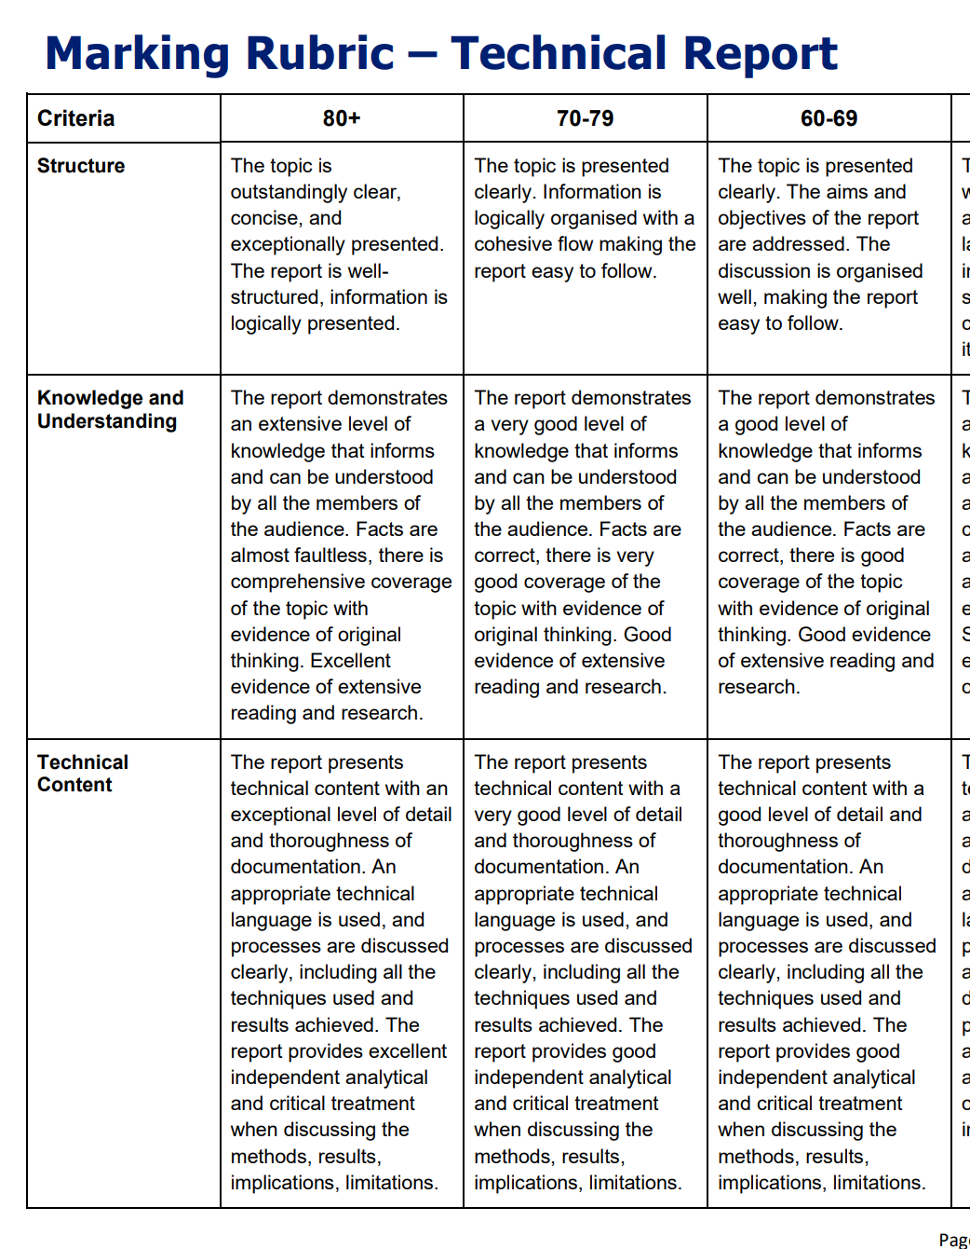

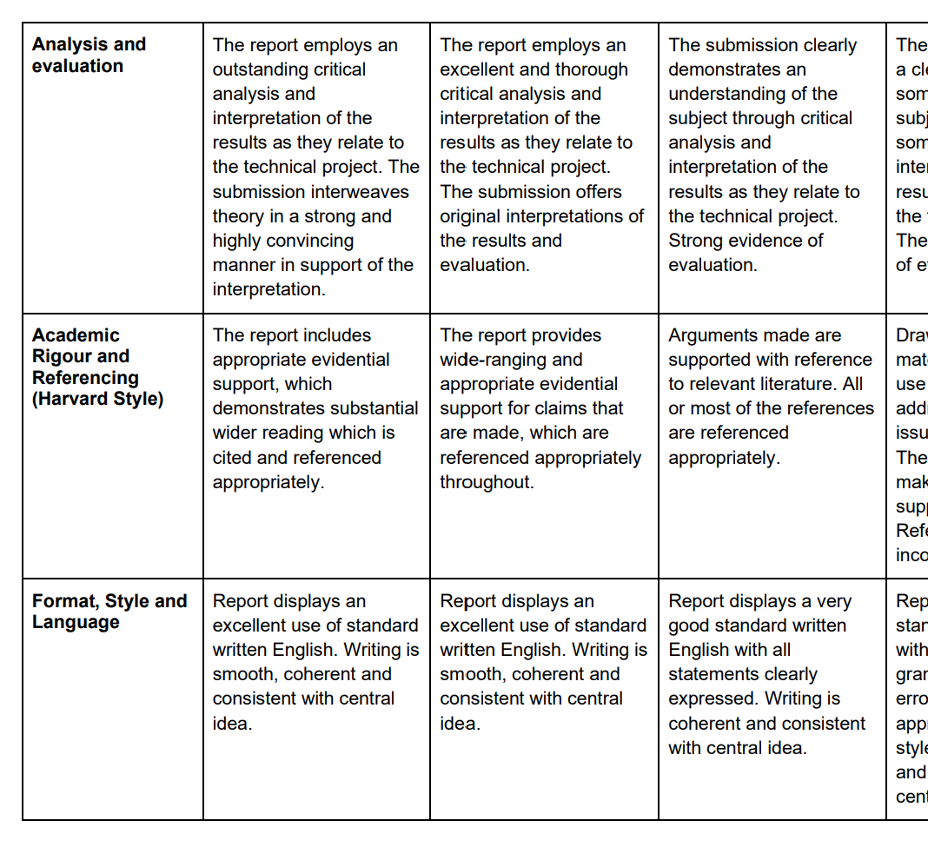

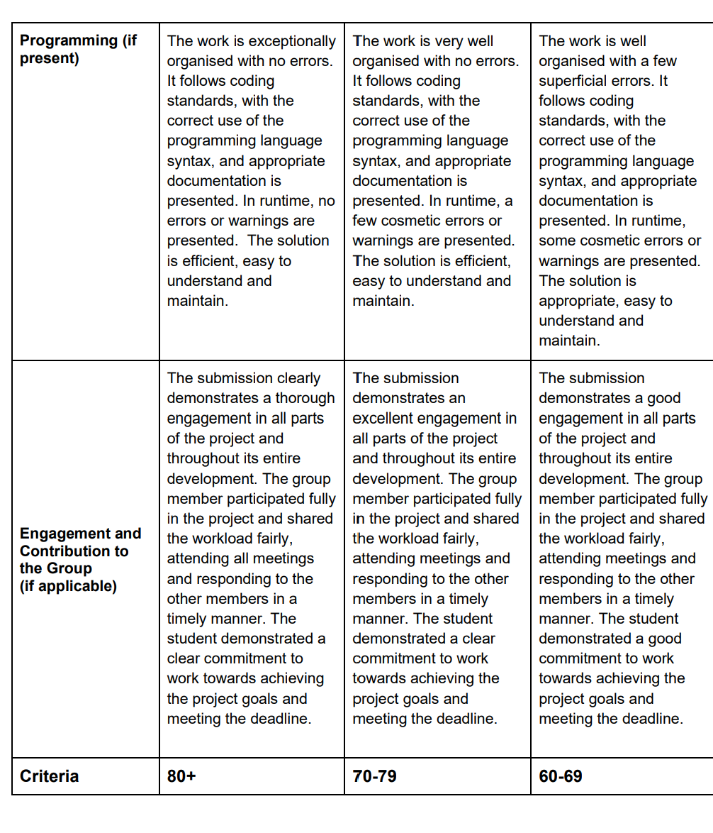

**Due:** Monday, 13 October 2025, 11:59 PM

## **Record Management System Project**

This group project is to design a record management system for a specialist travel agent. The system will manage three types of records: 1. Client records, 2. Flight Records and 3. Airline Company records.

You will need to create a system that allows the user via a Graphical User Interface to do the following:

1. Create a Record
2. Delete a Record
3. Update a Record
4. Search and Display a Record

The internal storage of the records will be a list of dictionaries. For example, records:list = [{},{}]. This will need to be stored on the file system as either binary (pickle), JSON or JSONL (JSON lines). You will need to save to the file system when the application is closed. The application will need to check for the existence of the records when it starts.

The record format should be:

**Client Record**:

* ID: int
* Type: str (type of record)
* Name: str
* Address Line 1: str
* Address Line 2: str
* Address Line 3: str
* City: str
* State: str
* Zip Code: str
* Country:str
* Phone Number: str

**Airline Record**:

* ID: int
* Type: str (type of record)
* Company Name: str

**Flight Record**:

* Client_ID:int
* Airline_ID: int
* Date: date/time
* Start City
* End City

You will need to write unit tests for each module in your code.

Each member of the team must have one or more of the following roles:

1. GUI / UX designer
2. Programmer
3. Project Manager
4. Tester

You must use source control for example GitHub, Bitbucket, or Gitlab, and the lecturer must have access to the code. Commit messages must follow the standard outlined in: Guidelines for Commits | [**PyInstaller 6.6.0 Documentation**](https://pyinstaller.org/en/stable/development/commit-messages.html)

The repo must be submitted to the VLE as a zip file. Each member must submit identical code.

The group must write a 500 word report which describes the application.

A [**project skeleton**](https://liverpool-online-study.com/pluginfile.php/412503/mod_assign/intro/Assignment%202.zip) is available to use.

### **To prepare for this assignment**

* Use the [**End of Module Module Assignment Group Discussion Forum**](https://liverpool-online-study.com/mod/forum/view.php?id=401220) to collaborate and communicate with your group members.
* In addition, you can use Microsoft Teams for asynchronous or synchronous communication (as a University of Liverpool student, you have access to a copy of the [**Microsoft Office suite**](https://www.liverpool.ac.uk/it/office/office365/).
* Review the module's resources, references, and the scenario above.
* Prepare any tool that your group would use to carry out this assignment.
* Estimate the work that needs to be done to complete this assignment and divide it among the members of your group. You can divide the work in many ways. You can divide the work by task, by sections of the reports, or by any other means that your group finds suitable for your needs. It may be helpful to keep a record of what you have decided.
* Your final submission must include the Meeting Minutes of all your virtual meetings.

### **Guidelines and Expectations When Working in Groups**

Here you will find important [**guidelines on effective group work**](https://liverpool-online-study.com/mod/assign/view.php?id=401218#guidelinesAccordion), recommended communication methods, and progress reporting.

### **Meeting Minutes**

Group members should establish at least three mini-deadlines/milestones/”meeting” dates throughout the development of their project. A “meeting” would typically be represented by a mini deadline by which each member would be expected to report on their task completion progress (see the [**guidelines on effective group work**](https://liverpool-online-study.com/mod/assign/view.php?id=401218#guidelinesAccordion)). Thus, group work would be typically asynchronous, without live meetings, although students can meet in real time should they wish to. In the latter case, group members should respect and accommodate members who cannot or do not want to meet in real time.

At the end of each mini-deadline/milestone/”meeting”, a member of the group must finalise the "Meeting Minutes", using the following document. All members of the group must agree on the minutes.

The minutes of all meetings must be included in the final submission.

[**Meeting Minutes Template**](https://liverpool-online-study.com/pluginfile.php/412503/mod_assign/intro/Computing%20-%20Group%20Assignments%20-%20Minutes.docx?time=1734718054091)

### **Peer Assessment**

Peer assessment provides a structured learning process for students to critique and give feedback to each other on their work. The process helps students develop lifelong skills in assessing and providing feedback to others and equips them with self-assess skills and improving their own work. As part of this group activity, you are asked to be involved in a peer moderation: you are required to assess yourself and each group member's contribution to the group product. You can download the [**Peer Group Assessment Form**](https://liverpool-online-study.com/pluginfile.php/412503/mod_assign/intro/Computing%20-%20Peer%20Group%20Assessment%20Form.docx?time=1734718072397) and submit it in the [**Peer Assessment Submission area**](https://liverpool-online-study.com/mod/assign/view.php?id=23191).

Peer assessment will be used to moderate/adjust the group grade. Each student will be able to see their group grade and their peer moderated/adjusted grade. Students won’t be able to see how other group members assessed their contribution.

### **Assessment Length**

The maximum assessment length will relate to the final report of 500 words. As per the assessment length policy, penalties will be applied to assessments which exceed this length.[**Click here to view the additional assessment length guidance.**](https://liverpool-online-study.com/pluginfile.php/412503/mod_assign/intro/Assessment%20Length%20Guidance.docx?time=1723566953558)

### **To submit your response to this assignment**

* **IMPORTANT:** Each student in the group must upload and submit a copy of the assignment to this page before the deadline indicated below. All members of the same group MUST submit an identical copy of the assignment. In case of differences, the assignment may be considered as not compliant with the requirements, resulting in a direct fail of the component. A student not submitting anything will be considered a non-submission case and will receive mark zero. Late submission penalties will be applied to individual group members for their own submission.
* Do not submit your Peer Group Assessment Form here, use the dedicated [**submission point**](https://liverpool-online-study.com/mod/assign/view.php?id=401219).
* Please make sure that all pdf and docx report files are not compressed (zipped). This is to ensure that the Turnitin similarity report can be generated for your submission.
* You should submit meeting minutes as part of your assignment.
* Please, review the Grading Criteria located in the "[**Additional Resources**](https://liverpool-online-study.com/course/view.php?id=3299&section=2)" section.